**CP5046 ICT PROJECT 1 - ASSESSMENT TASK 1**

**PROJECT DOCUMENTATION**

**Team Number :** 5

**Group Member:** Xuan Hai Nguyen (12885170)

Gagandeep Singh (1312630)

Rajbir kaur gill (12864385)

 Anay Gharat (13131701)

**Lecturer Name:** Laura Antochi

Contents

1. Group Information and Individual Contribution 3

2. Project description for non-ICT-technical stakeholders and general audience 4

3. Project planning and Scope 5

4. Project client agreed to the scopes of alpha-release and final release (Scan of of agreement) 7

5. Project development and release ICT infrastructure 10

References 15

## **Group Information and Individual Contribution**

Our team number is 5 and we are four members in our group and we are going to create a website about Indian grocery store. Our client gave us an opportunity for creating this website. Our team is very happy to get this opportunity from client to show our work and our practical skills in this website. We divided the task about creating the website into the following group members.

Team member 1**:** Xuan Hai Nguyen - 12885170

**Role:**

Designing Project planning and Prototypes

Designing Page for Home Page and Database Connectivity

**Contribution:**

As a Developer, Hai used GitHub to join with the group members. The individual contribution was to estimate time available and User story for project planning. Also, the Home page and Database connectivity were created to demonstrate and justify the prototypes using WordPress**.** However, Hai took responsibility for combine all the component from each members.

Team member 2**:** Gagandeep Singh- 1312630

**Role:**

Designing Project Scope

Project Development and release ICT infrastructure.

**Contribution:**

Gagandeep Singh has used GitHub for joining with group members. The individual work was to define the project scope, Software and Programming languages to be used in the project. I also define the configuration management which includes data sharing tools and other development tools including XAMPP server, Dreamweaver.

Team member 3**:** Rajbir Kaur- 12864385

**Role:**

Project description for non-ICT technical stakeholders and general audience.

**Contribution:**

I used GitHub for joining with group mates. I prepared justification for the project. I describe the project goals that how they will be delivered to the client.

Team member 4:Anay Gharat - 13131701

**Role:**

Agreement preparation and signed from the client

**Contribution:**

I worked on the Project Client Agreement. I informed client about the Alpha release and discussed everything with client about requirements and deliverables.

## **Project description for non-ICT-technical stakeholders and general audience**

## 2.1 Justification of the Project:

The project named “Indian grocery store” is developed for our client. This project is being developed as information website to developing a new grocery store service for Indian customers. Other purpose of this website is the grocery stores should deliver the groceries to the customers‟ homes. For this to be possible there should exist tools which enable the customers to buy the groceries without visiting the stores themselves. This website is designed to mostly target the customer who has no time for shopping. This website is like mobile shopping applications enable the customers to buy the groceries without leaving their homes. The reason behind this development is to measure the customer needs and time. The main reason to develop this website is to act faster and efficient alternative to the one that exists in today’s market, also the new UI (user interface) to be designed would provide a refreshed feeling to the website. Our main intention is to satisfy our client and complete the project according to client requirements.

2.2. Project Goals and deliverables

The main objective of this project is to create a website for Indian customers mainly being targeted at customers who has no time to go market The website is being designed to give a better hand on experience for the users, with interactive UI at the same time that can perform faster and to be more efficient than the existing website that serves the same purpose. The website will be developed in such a way that the website will ask the customer to give their feedback (if any).

**Deliverables**

* Live website
* Coding
* Documentation
* Responsive theme
* Database design
* Login and Logout page

2.3 Milestones

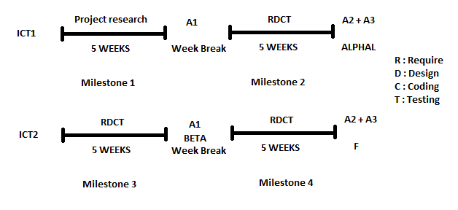

Meanwhile all the activities are on time and in progress as we want. We all together completing all the tasks on timeframe. The most important job to fulfill client requirements rather than other things that client don't want. As per time schedule we are doing our work on time.

Milestone 1 **(Before 6 week)**

**Project research and decide design pattern**

This milestone has achieved in time period. We show all the research to our client the things we are going to include in our website and we did not finalize design for our project.

Milestone 2 **(10th week)**

**Website alpha release.**

This will be done on 10th week of study calendar. In following weeks, we will finalize the alpha release website and test it or we will check it with the domain that we got from local server.

Milestone 3 **(1st week of SP 23)**

Our client will provide us Domain Name and Hosting.

Milestone 4 **(10th week SP23)**

**Final release**

Beta release is release in which we test website and corrected all the bugs in desired timeframe and it will be in the final week SP23.

The milestone has been setup by keeping time as the primary concern. The allotted time and duration of this website development is realistic in nature, so the deliverables are delivered to the client on the date promised.

**Scope of Alpha Release**

Alpha is a Greek world that stand for number 1, which means first step to implement the project. Website design will be according to client demand. Client can change his mind any time to make some changes into the website and can tell developers to add more into the website until the final release.

## **Project planning and Scope**

3.1 User Stories

1. *Title:* home page

*Description:* Registration form – User name, e-mail address, phone number and password to be validated.

1. *Title:* Product Categories

*Description:* Product picture and Price would be displayed in sub categories.

1. *Title:* Deals & Offerings

*Description:* New arrivals, discounts and occasional discounts will be displayed here.

1. *Title:* Registration

*Description:* Registration form – User name, e-mail address, phone number and password to be validated.

1. *Title:* Login & Logout

*Description:* User name and Password

1. *Title:* Shopping Cart

*Description:* Content management, total price with Discount, unit price, quantity, subtotal

1. *Title:* Contact Us

*Description:* Phone number, Email, map, trading days and hours

3.2 Project planning

**Time available**

Time for **Milestone 1** = 5 weeks

Time for break = 1 week

Time for **Milestone 2 (Alpha release)** = 5 weeks

Total time available for Project = 11 weeks

Number of team members = 4

Days working per week = 2 days

Total days available = 11 x 4 x 2 = 88days

Days available for **Milestone 1** = 5 x 4 x 2 = 40days

Days available for **Milestone 2** = 5 x 4 x 2 = 40days

Days available for documents A1, A2 +A3 = 1 x 4 x 2 = 8 days

**Time estimate for Alpha release:**

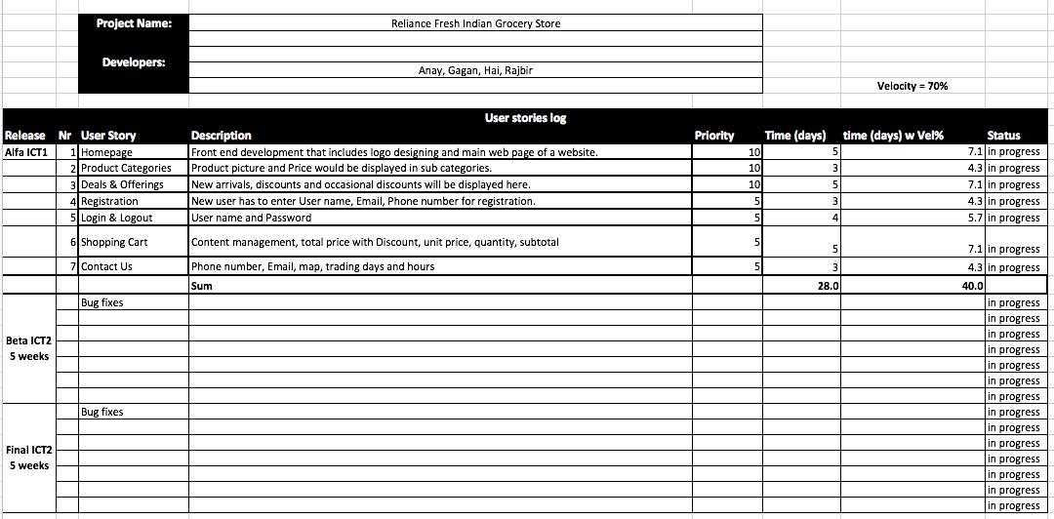

The total user story estimates 28 days, after applying velocity which is a percentage, start with 70% for productive as an initial estimate and get 40days for the result.

The graph shows the time estimate for 8 users story and the time with velocity. The Sum estimate user story (40 days) satisfy the condition smaller or equal the time available (40 days for Alpha release.

## **Project client agreed to the scopes of alpha-release and final release (Scan of of agreement)**

4.1 Project scope:

1. User stories: Gathering all the information and requirements from the client.
2. Software Installation: Installing the Word Press software in our computer systems.
3. Strategies: Dividing the work in all team members.
4. Development: Develop website according to the client.
5. Basic Setups: Create the web pages such as login, logout and registration etc.
6. Testing: Website will be upgraded as per client’s requirement.
7. Execution: Executing the website and protect it from bugs.

4.2 Project client agreement

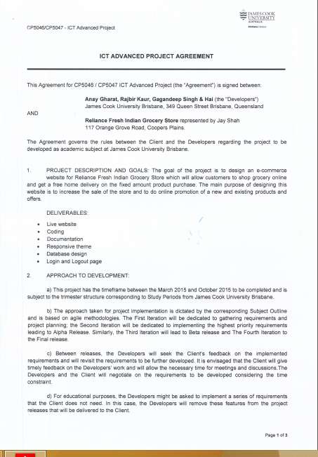

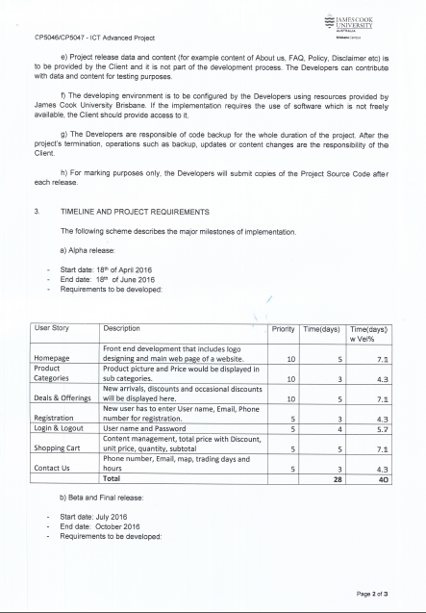

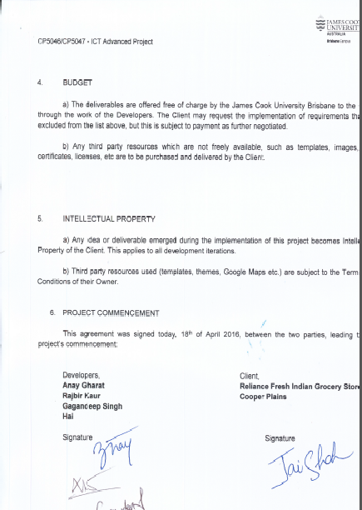

## **Project development and release ICT infrastructure**

5.1 Configuration Management

**GitHub:**

GitHub is an open source project started by Linux Torvalds. GitHub, like other version control systems, manages and stores revisions of project. Apart of code, Git could be used to manage any other type of file like word file etc. GitHub is very convenient for projects as it provides free repositories for open source software development. When we make changes, those changes are made directly to the central repository. (Finley, 2012)

**Project Tools:**

Data sharing tools are as follows:

**JCU Mail:**

JCU mail is a collaboration tool of exchanging files among team members and we can also use JCU mail to send and receive mails from client.

**Blackboard:**

Blackboard is another collaboration tool offered by JCU to exchange files between team members during project.

**Dropbox:**

Dropbox can be used to share all types of files needed in project whether they are texts, videos, pictures etc.

5.2 Project Tools

5.2.1. Development environment

**WordPress:**

We are going to use WordPress to build a website for our project. WordPress is an open source project, i.e., there are hundreds of people all over the world working on it. WordPress is a full content management system so that you can add plugin, widgets and third party themes. It is built on PHP and supported by MySQL. (Hou-Sandí)

5.2.2. Programming Languages

**JavaScript:**

JavaScript is a programming language of HTML and Web and is easy to use. JavaScript can change HTML Attributes, Styles (CSS) and can validate data. It supports numerous data types such as String, Number, Boolean and Array as C language uses.

**PHP:**

PHP is acronym for Hypertext Pre-processor and is widely used Open Source scripting language. The scripts of PHP are executed on server. PHP is free to use and download.

**CSS:**

Cascading Style Sheets(CSS) is a style sheet language used for describing the presentation of a document written in mark-up language. It is used to set the visual style of web pages and user interfaces.

5.2.3. Tools support

**Project collaboration tools:**

**Dreamweaver:**

We will do all HTML coding by using Dreamweaver as it is very easy to use and we have experience of this tool in our previous studies.

**Development tools:**

**XAMPP**

XAMPP is an open source web server tool which can be used on various platforms. It has been designed to review the work of web page developers and programmers using their computer systems even without connection to it. XAMPP can be used to create and configure with database which is written in MySQL. We just need one zip file to use the XAMPP and just need to download this file from web and run the application. (Z, 2011)

5.3 Testing tools

When the designing of the project will have done. Unit testing will be performed for each individual segments. A Unit test should check that one piece of code such as function or method, runs probably and returns the expect result. Combine testing will be done by Unit. After the Unit testing, smoke testing would be done to check the efficiency of the application.

5.4 Prototypes

Prototypes are demonstrated to justify the proposed Alpha-Release.

1. Home Page

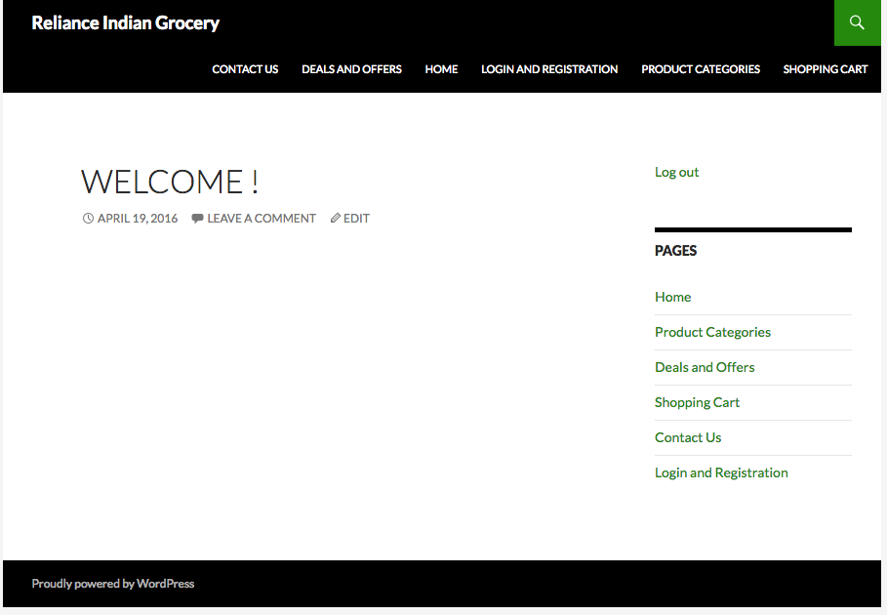

1. Login and Logout Page

The link Logout in the right hand side of this page accept user logout and it link to Login pages a.

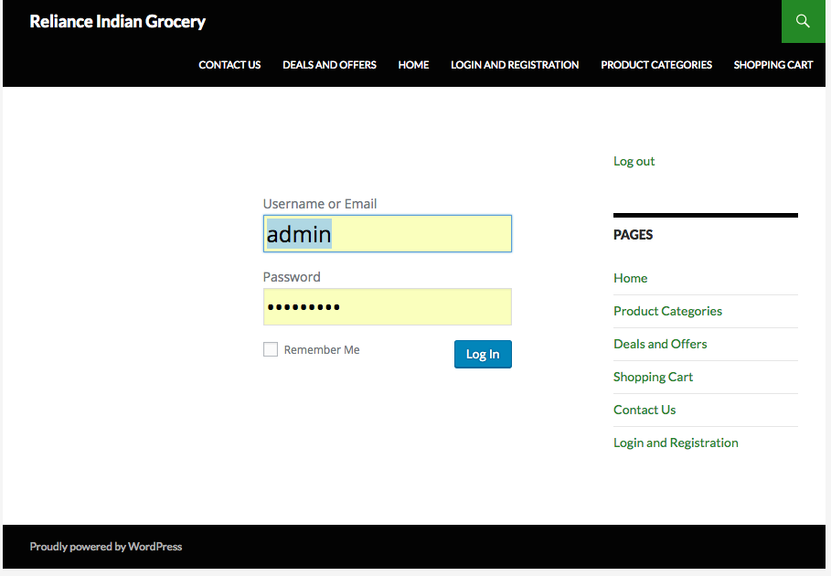

1. Registration Pages

After the User register is successful, the information of the user will be stored in the database and accept user to login automatically.

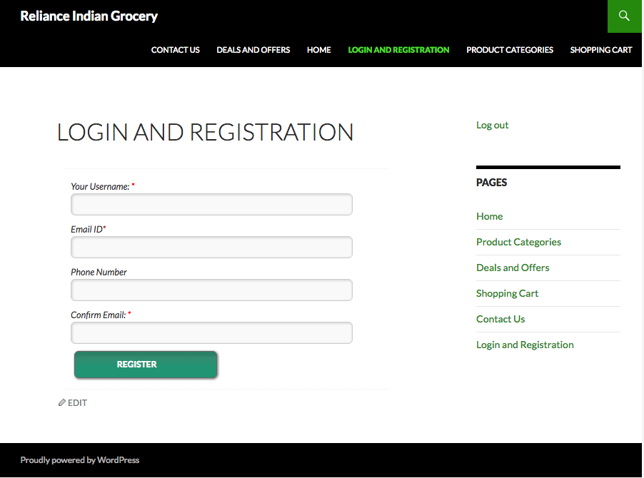

1. Contact Us page

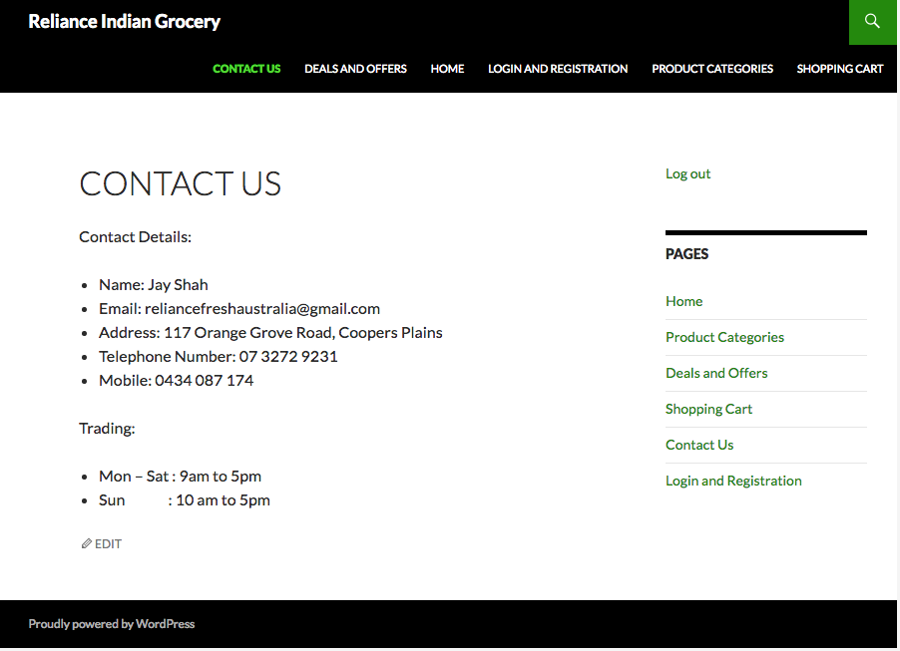

1. Deals and Offers page



1. Product Categories page

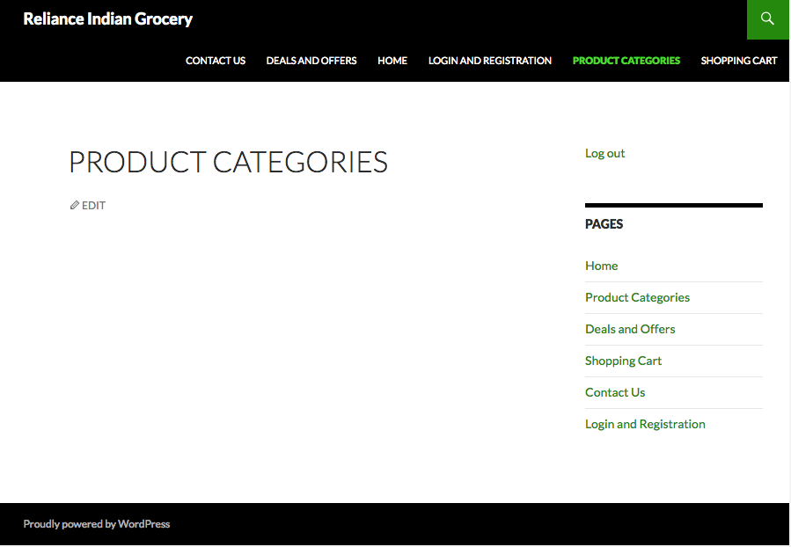

1. Shopping Cart page

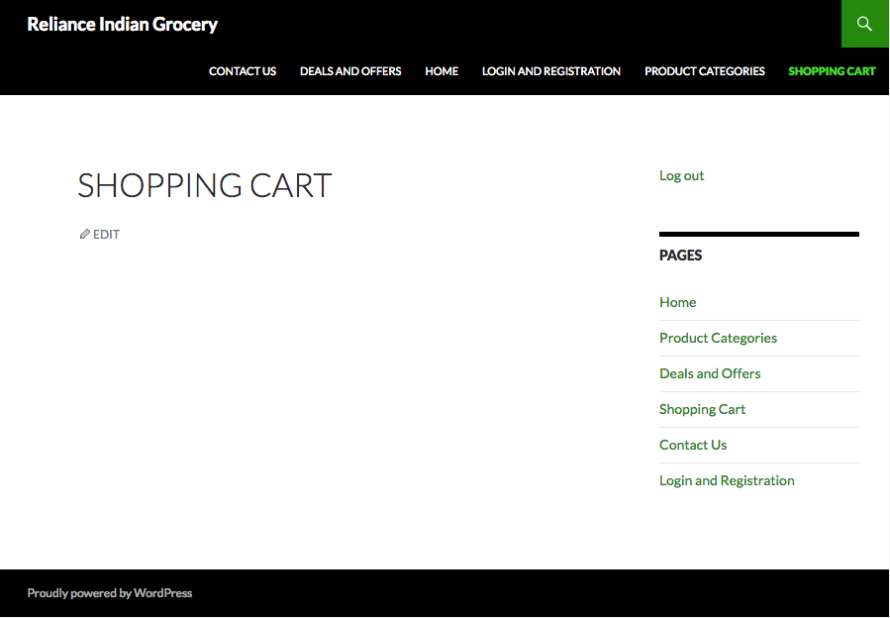

## References

Finley, K. (2012). http://techcrunch.com/2012/07/14/what-exactly-is-github-anyway/.

Hou-Sandí, H. (n.d.). https://wordpress.org/about/.

http://www.w3schools.com/js/js_intro.asp. (n.d.). http://www.w3schools.com/js/js_intro.asp.

https://en.wikipedia.org/wiki/Cascading_Style_Sheets. (2016).

Z, E. (2011). http://www.qwhatis.com/what-is-xampp/.

Rouse, M. (2007, November). What is Ajax (Asynchronous JavaScript and XML)? - Definition from WhatIs.com. Retrieved from http://searchwindevelopment.techtarget.com/definition/Ajax

http://localhost:8888/wordpress/home/

<http://searchsoa.techtarget.com/definition/HTML>

(https://en.wikipedia.org/wiki/Cascading_Style_Sheets, 2016)